Rotary Club of Kathmandu Mid-Town
Breakfast Chatter




16 March 2012 The Weekly Bulletin of Rotary Club of Kathmandu Mid-Town Bc-3.16/011-12

District: 3292 Web: www.rotarymidtown.org.np Club Id : 26776

MARCH IS LITERACY MONTH
Teach children the value of life, and that they should respect others, no matter what sex or caste they belong to. If you can change their way of thinking, and introduce them to a better way of life,
you will be doing them and the entire community a great service.

9 March, Friday
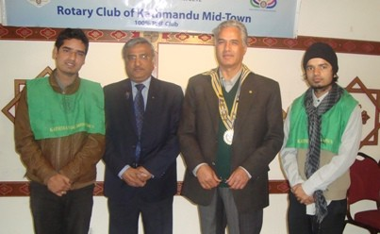
It was the day for Rotaracts. Rotaract Club of Kathmandu Mid-Town was scheduled to
provide presentation on 2011-12 activities reporting to the parent club. Rtr Samir Nepal,
President of Rotaract Club, on the occasion, introduced PE Kishore Acharya. He provided
an interesting Power Point presentation on avenue-wise activities reporting – dealing with
various projects successfully implemented, ongoing projects, club visits, club bulletins, board
meetings, membership, etc. They also trained Interacts and provided mentoring services to
Interact clubs.
President Samir thanked parent club, parent club President Dr Som, mentor Dr Chandra
Lekha for their continuous support and encouragement and hoped such support would
continue over time. He also stressed that whatever they have been able to achieve over the
years would not have been possible had there been no such support. The parent club
presidents and other club members have been providing all support, encouragement and
other help in whatever way possible all the times.
Rtr Samir Nepal

Weekly Meetings and Programs :
Date | Program/Speaker | Program/Topics of Presentation
16 March 2012 | Dr Niti Rana | The Phenomenon of school bullying
23 March 2012 | Fionna Heiton | Play-based learning and child friendly teaching in schools
30 March 2012 | Archana Thapa | Alternative History: Women's Personal Stories
6 April 2012 | CP Roop Jyoti | Why Vipassana Meditation?

PETS-2012 :
This year the PETS is in Pokhara!
President-Elect Training Seminar for PEs is scheduled to be held in Pokhara on 4 and 5 Chaitra 2012, (17-18 March) in Hotel Pokhara Grande, Birauta, Pardi, Pokhara.
In Rotary, PETS is mandatory, that is, PEs will not be eligible to take over as President of the Club unless they attend the PETS which is held this time of the year every year.
PE Devendra will be in Pokhara for attending the PETS-2012.
Rtn Bijaya Laxmi Koirala (Mobile:9846020809) is Chairperson of the PETS Organizing Committee.

John Hewko outlines five priorities for strengthening Rotary’s image:
A number of major initiatives are underway that will help Rotary International’s professional staff, the Secretariat, be a more effective, efficient, and useful resource for clubs and districts.
Addressing the fifth plenary session of the International Assembly, an annual training event for incoming district leaders, RI General Secretary John Hewko spelled out five priorities for strengthening the organization, ones he said would put Rotary on the best footing possible as it begins its second century.
“Rotary is an organization with an incredible history and there is no question that its best years are yet to come,” Hewko said. “These five priorities, as well as many others, will strengthen our great organization and have a significant, positive impact down to the level of the club and individual Rotarian.”
Eradicating polio:
Hewko said the first priority is the eradication of polio, Rotary’s signature global initiative since 1985. Eradication of polio will save hundreds of thousands of children from suffering from the disease, and save the world between US$40 billion and $50 billion in health care costs over the next 20 years.
A robust public relations campaign is underway to publicize Rotary’s work in polio eradication.
“Our success in polio eradication will set the stage for the next global initiative that Rotary chooses to tackle, whatever that may be,” Hewko said.
Future Vision
The second priority is implementing RI’s Strategic Plan and the global launch of the Future Vision Plan, The Rotary Foundation’s new grant making model. Hewko said Future Vision is the second most important Rotary initiative, after polio, and it will be important to get district leaders on board to support the launch.
“Successful implementation of Future Vision will lead to projects and programs in the six areas of focus that are better designed and more sustainable and scalable, and that will lead to greater impact,” he said. “This, in turn, will increase our profile, reputation, and public image and will make Rotary more attractive to outside funding sources. Future Vision will bring considerable and tangible positive benefits to clubs and districts.”
Cont’d
Source: Arnold R. Grahl/Rotary International News


Let’s look at the things that we can do better, things that we should be changing, and things that we
haven’t started working on yet. I believe we must have the wisdom and courage to see these and identify
them and engage ourselves in them.
RI President Kalyan Banerjee

On Lighter Side : Click here ⇩


A thought for the day:
A proud man always looks down on people.
And as long as you are looking down on someone, you cannot see something that’s above you.”
- CS Lewis

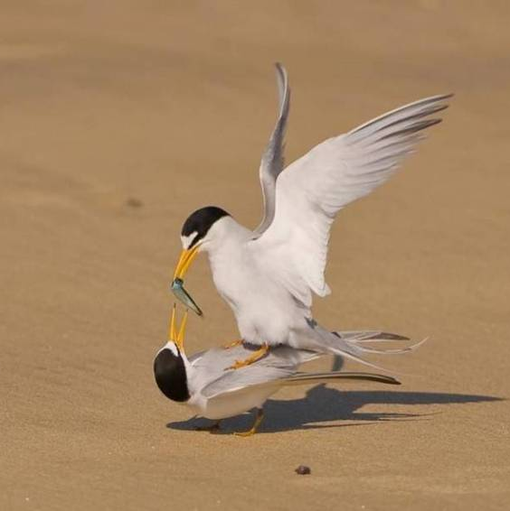
Nature and photography

Lifestyle changes can help prevent 30% of cancers:
More than 30 percent of cancers can be prevented by lifestyle changes, the World Health Organization said. Among key risk factors for cancer are tobacco and alcohol consumption, a diet low in fruit and vegetable intake and lack of physical activity. “Tobacco use is the most important risk factor for cancer causing 22 percent of global cancer deaths and 71 percent of global lung cancer deaths,” the UN health agency said. Halting tobacco use, for instance, could therefore help cut cancer mortality rates. According to latest available figures dating to 2008, cancer caused 7.6 million deaths worldwide during the year, making up about 13 percent of global mortality. Lung, stomach, liver, colon and breast cancers caused the most fatalities. About 70 percent of all cancer deaths in 2008 occurred in low and middle-income countries. The WHO projected that deaths from cancer will continue rising, and will hit an estimated 13.1 million in 2030.
Source: The Rising Nepal

Please send project/activity information, suggestions and photos etc to :
BC Editor: RR Shrestha email: rryes@wlink.com.np

16 March 2012 The Weekly Bulletin of Rotary Club of Kathmandu Mid-Town bc-3.16/011-12

